Supplementary Figures for Paper: “Decoding and Rewiring Promoter Architecture Using Large Language Models and Diffusion Frameworks”

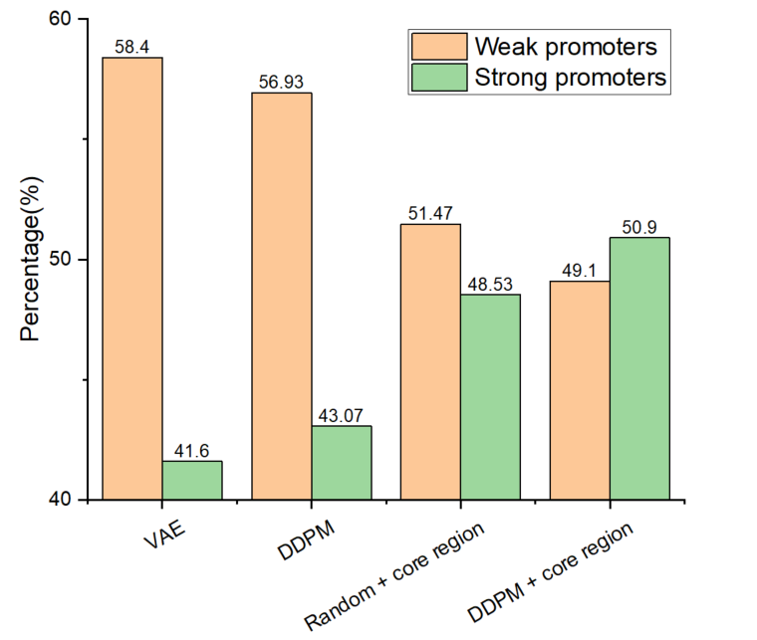
Supplementary Figure 1. Predicted strength distribution of synthetic promoters generated by different methods. The fine-tuned large language model was used to predict the proportion of weak (orange) and strong (green) promoters among sequences generated by VAE, DDPM, Random + core region, and DDPM + core region strategies. VAE and DDPM tend to produce a higher fraction of weak promoters, whereas incorporating the natural core region (Random + core region, DDPM + core region) yields a more balanced distribution.
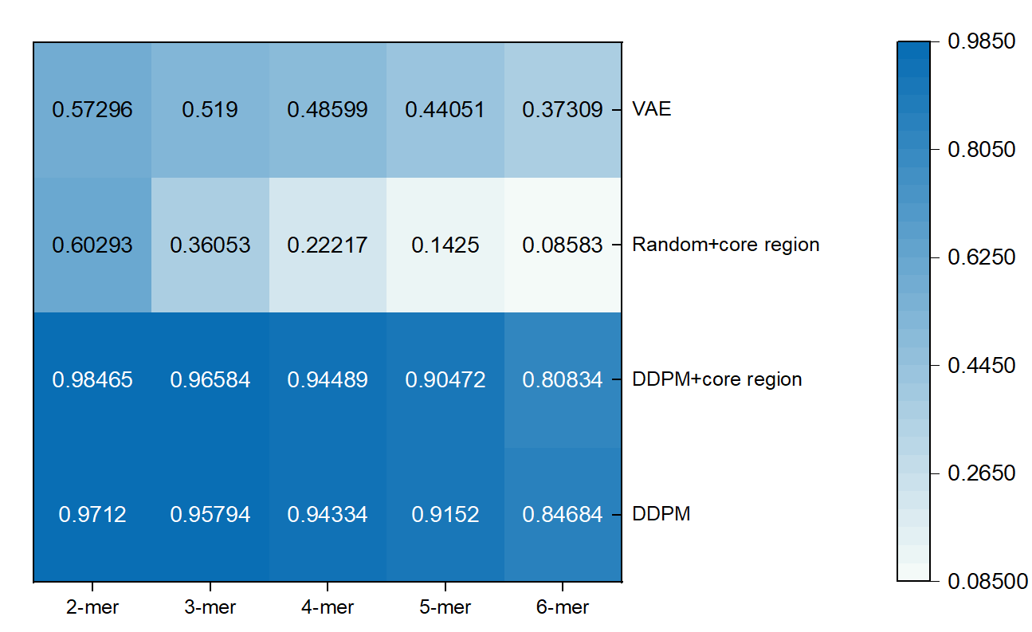
Supplementary Figure 2. Preservation of non-core sequence features in synthetic promoters. We computed k-mer (2–6 mer) frequency correlations (PCC) between the non-core regions of the natural promoter test set and all generated promoters. The results show that DDPM and DDPM+core region maintain strong similarity to natural promoters (PCC values ranging from 0.81 to 0.98), demonstrating their ability to capture distal sequence features that contribute to promoter strength. In contrast, VAE and Random+core region display substantially lower correlations (minimum PCC ≈ 0.09), indicating weaker modeling of non-core patterns. These findings confirm that DDPM-based approaches preserve functional properties of non-core regions while enabling high-performance promoter design.

